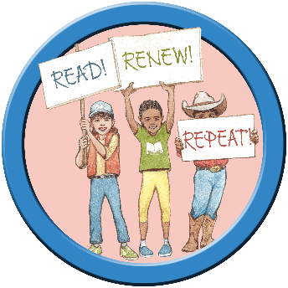
2024 LORI Summer Reading Mini-Grants: Accepting & Managing Your Award Instructions and FAQ

Overview
LORI Summer Reading Mini-Grants are available to all public libraries to support reading and learning programs this summer. The program will reimburse pre-approved expenditures for programming at libraries this summer which fall into OLIS’ priorities for summer programming. Libraries may request up to $600 for youth activities and up to $300 for adult activities. Library systems may request an additional $300 per location for youth activities.

Instructions
All grant management will be done in the State of RI eCivis Grant Management Portal. Additional user guides and help resources for managing your grant in eCivis are available at the State of RI Resources for Applicants and Subrecipients.

Accepting Your Award
- When your request form has been accepted, OLIS will invite you to receive your award in eCivis.
  - The Library Director must accept the invitation
  - The Library Director must create a profile for the library
- OLIS will issue a Grant Agreement and Federal Assurances package to be signed via DocuSign
- OLIS will return your signed documentation as well as your accepted Request Form via the eCivis GMS.
- Library Director accepts the award, OLIS confirms.
- Your Library now has a Summer Reading Grant! You may begin the activities outlined in your Interest Form.
- Library Director may add Youth Services and/or Adult Services contact to grant team using the “Manage Grant Team” button
- All grant management will be conducted through the eCivis GMS portal.

Managing Your Award
- In the eCivis portal you will see the 2024 Summer Reading Mini-Grants in your list of grants.
- Click on the Grant to see all grant activities and their due dates
- When you are ready to request a payment, no later than August 19, complete your Financial Report in eCivis, ensuring that you check off “This report is a reimbursement request”
  - Fill out the amounts you spent in your budget categories
  - Write a brief narrative of how the funds were spent
  - Upload all accompanying back up documents
    - Back-up documents must show that the library has paid for the items/service in question, including a detailed list of items/services and the total amount paid
    - Back-up can include invoices marked paid, scanned receipts, canceled checks, packing slips, credit card payments, or any combination thereof that meets the criteria above
- If you want or need to change your activities or budget, you should submit an Amendment Form through the eCivis GMS portal. You cannot submit an amendment if you have an open Financial Report.
- When the grant period is over, no later than September 23, please submit the final activity report which includes a brief narrative and asks you to report numbers toward the OLIS program goals in the following areas: public programs held, attendance at public programs, circulating materials acquired, circulating kits created, and take and make kits distributed.
- To close out your grant, you will need to fill out the Close-Out Report by October 7. This report will pull in your details from your financial report and will not require you to make significant changes. Once you have closed out the grant, you can no longer request funds or submit activity reports.

Contact
For questions about grant management in eCivis contact:
- Nicolette Baffoni, nicolette.baffoni@olis.ri.gov
For questions about amendments or financial back up documentation, contact:
- Danielle Margarida, danielle.margardia@olis.ri.gov
- Emily Goodman, emily.goodman@olis.ri.gov

